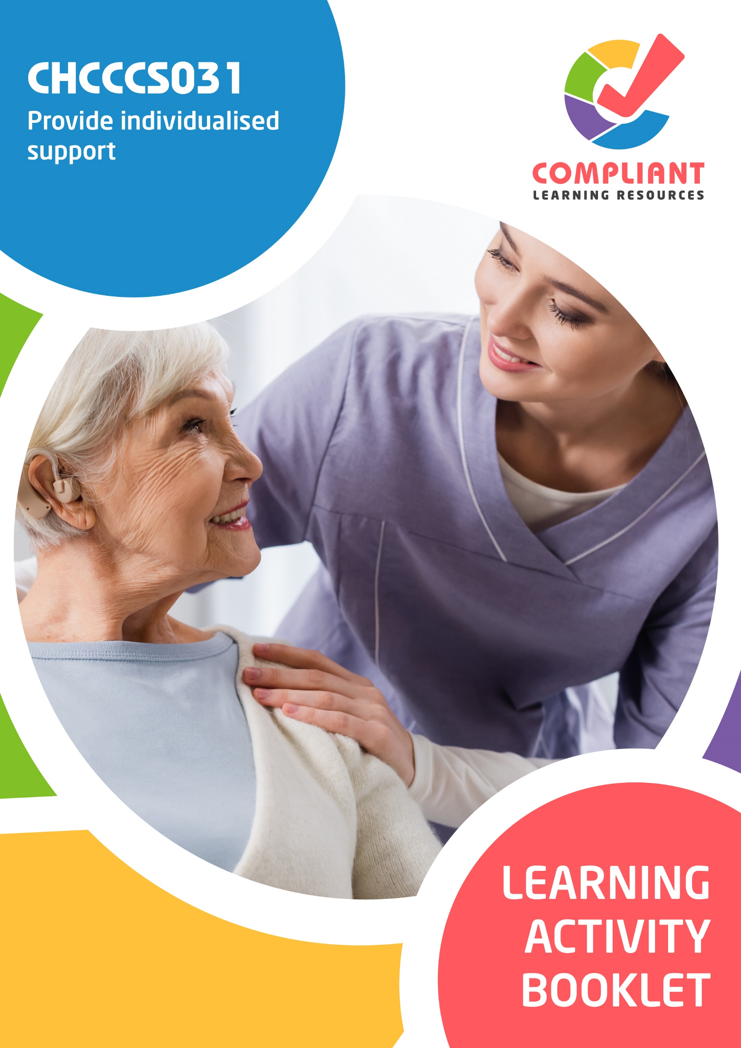

**Copyright**

This document was developed by Compliant Learning Resources.

© 2023 Compliant Learning Resources.

All rights reserved.

No part of this publication may be reproduced, stored in a retrieval system, or transmitted in any form or by any means, electronic, mechanical, photocopying, recording, or otherwise without the prior written permission of Compliant Learning Resources.

**Version Control & Document History**

|  |  |  |
| --- | --- | --- |
| **Date** | **Summary of Modifications** | **Version** |
| 13 January 2023 | Version 1.0 released for publishing | 1.0 |
| 25 May 2023 | Version 1.1 endorsed for use  Modified Activity 2.1 for clarity | 1.1 |
| 22 August 2023 | Version 1.2 endorsed for use  Fixed wording issues | 1.2 |

# Table of Contents

Overview 4

Learner Instructions 5

Learner Information 5

Trainer Information 5

Resources Required 6

Work Health and Safety 6

Reasonable Adjustment 7

Formative Activities 8

I. Determine Personal Support Requirements 8

Activity 1.1 8

Activity 1.2 10

II. Provide Support Services 11

Activity 2.1 11

Activity 2.2 13

Activity 2.3 14

III. Monitor Support Activities 15

Activity 3.1 15

Activity 3.2 16

IV. Complete Reporting and Documentation 17

Activity 4.1 17

Activity 4.2 18

# Overview

**CHCCCS031 – Provide individualised support (Release 1)**

This unit describes the performance outcomes, skills and knowledge required to organise, provide and monitor personal support services for a person within the limits established by an individualised plan. The individualised plan refers to the support or service provision plan developed for the person accessing the service and may have different names in different organisations.

This unit applies to workers who provide care or support under direct, indirect or remote supervision. Work is carried out in a manner which supports independence as well as the physical and emotional wellbeing of the person receiving support.

The skills in this unit must be applied in accordance with Commonwealth and State/Territory legislation, Australian standards and industry codes of practice.

No occupational licensing, certification or specific legislative requirements apply to this unit at the time of publication.

**A complete copy of the above unit of competency can be downloaded from the TGA website:**

<https://training.gov.au/Training/Details/CHCCCS031>

# Learner Instructions

This Learning Activity Booklet contains formative activities that learners will complete in the classroom or a similar environment.

These formative activities include knowledge questions to test your underpinning generic knowledge and practical activities to test your skills relevant to the unit/s of competency.

These formative assessments are used by your trainer to complement both the learning and training processes, and to evaluate how you are progressing throughout these processes.

You may reference your Learner Guide and other learning materials to complete the activities included in this workbook.

**IMPORTANT:**

**The completion of the formative assessments and learning activities included in this workbook DOES NOT lead to a Qualification or a Statement of Attainment (SOA).**

## Learner Information

|  |  |
| --- | --- |
| Learner name |  |
| Phone |  |
| Email |  |

## Trainer Information

|  |  |
| --- | --- |
| Trainer name |  |
| RTO name |  |
| RTO phone |  |
| RTO email |  |

# Resources Required

Resources needed to complete activities included in this workbook include:

* Computer with Internet, email access, and a working web browser
* Installed software: MS Word, Adobe Acrobat Reader
* Learner guide
* Volunteers to participate in a role play activity

# Work Health and Safety

Both the trainers and learners have duty of care in ensuring that the learning environment is free from hazards that may pose risks to their health and safety.

According to WHS legislation, trainers and learners must take reasonable care while undertaking the activities included in this workbook in the learning environment.

# Reasonable Adjustment

‘Reasonable adjustment’ in VET is the term applied to modifying the learning environment or making changes to the training delivered to assist a learner with a disability. A reasonable adjustment can be as simple as changing classrooms to be closer to amenities or installing a particular type of software on a computer for a person with vision impairment.

**Why make a reasonable adjustment?**

We make reasonable adjustments in VET to make sure that learners with disabilities have:

* The same learning opportunities as learners without disabilities, and
* The same opportunity to perform and complete assessments as those without disabilities.

**Reasonable adjustment applied to participation in teaching, learning, and assessment activities can include:**

* Customising resources and assessment activities within the training package or accredited course
* Modifying the presentation medium
* Learner support
* Use of assistive/adaptive technologies
* Making information accessible both before enrolment and during the course
* Monitoring the adjustments to ensure learner needs continue to be met

**Assistive/Adaptive Technologies**

Assistive/adaptive technology means ‘software or hardware that has been specifically designed to assist people with disabilities in carrying out daily activities’ (World Wide Web Consortium - W3C). It includes screen readers, magnifiers, voice recognition software, alternative keyboards, devices for grasping, visual alert systems, and digital note-takers.

*(Adapted Reasonable Adjustment in teaching, learning and assessment for learners with a disability - November 2010 - Prepared by - Queensland VET Development Centre)*

**IMPORTANT:**

**Reasonable adjustment made for collecting learner assessment evidence must not impact the standard expected by the workplace, as expressed by the relevant unit/s of competency. For example, if the assessment were gathering evidence of the learner’s competency in writing, allowing the learner to complete the assessment verbally would not be a valid assessment method. The method of assessment used by any reasonable adjustment must still meet the competency requirements.**

# Formative Activities

## I. Determine Personal Support Requirements

### Activity 1.1

|  |
| --- |
| **SCENARIO**  You are a community care worker who is assigned to care for Caitlin Summers. Caitlin has had arthritis in her hands and ankles for seventeen years. Her partner died twelve years ago. Since then, Caitlin has lived alone. She is determined to remain independent and stay in her own home for as long as possible.  Caitlin enjoys and can still participate leisure activities such as reading and swimming. The daily living activities she has difficulty with are the following:   * Dressing and grooming * Cooking meals * Household chores (e.g. cleaning, gardening, etc.)   Despite her finding the activities difficult due to her arthritis, she still manages to do them. Caitlin has expressed to you that she would like to use assistive technologies that can help reduce hand fatigue. |

|  |
| --- |
| Shown on the next page are a profile and individualised plan. Complete the template below using all the information provided in the scenario. |

|  |  |  |  |  |  |
| --- | --- | --- | --- | --- | --- |
| **PRofile** | | | | | |
| **Name:** |  | | | | |
| **Needs:** |  | | **Strengths and Preferences:** |  | |
| **Goals:** |  | | **Timeframe to Achieve Goals:** |  | |
| **Individualised plan** | | | | | |
| **ADL/IADL** | | **Support Service** | **Resources Needed** | | **Required Personnel Assistance** |
|  | |  |  | |  |
|  | |  |  | |  |
|  | |  |  | |  |

### Activity 1.2

|  |  |
| --- | --- |
| **True or False**  Review the statements below about common struggles that people receiving support may face. Indicate whether each statement is True or False.  Tick the box that corresponds to your answer. | |
|  | |
| TRUE  FALSE | 1. Support services are often so limited that individuals go to extraordinary lengths to be eligible to receive support. This process often leaves them feeling demeaned and humiliated. |
| TRUE  FALSE | 1. In Australia, people with impairment have a legislated right to access aids, equipment and technology for daily living. |
| TRUE  FALSE | 1. Many Australians with impairment want to live independently in their communities and are able to access the support they need to do so. |
| TRUE  FALSE | 1. There are still widespread misconceptions and stereotypes about disability and ageing that influences the attitudes of employers and recruiters. |
| TRUE  FALSE | 1. For many people with impairment, the built environment acts as a powerful barrier to their social inclusion. Their inability to access the facilities in their communities limits their independence. |

## II. Provide Support Services

### Activity 2.1

|  |
| --- |
| **SCENARIO**  Matthew lost function in his arms, legs and trunk due to a spinal cord injury. He finds it extremely difficult to take a shower or bath. As such, one of the support services you provide to Matthew as his care worker is bed bathing. This is to maintain his hygiene. |

|  |
| --- |
| **Role Play Activity**  Role play the scenario with a volunteer to perform a sponge bath for a person with no mobility while demonstrating the practical skills listed in the checklist in the next page.  Perform this activity while being observed by your trainer. If your trainer is not available to directly observe you, you may video record the role play activity and submit the recording to your trainer.  **Your role**  For this activity, you will take the role of Matthew’s residential care worker.  **The volunteers’ role**  For this activity, the volunteer will take the role of Matthew. |

|  |  |  |
| --- | --- | --- |
| **Role Play Checklist** (For trainer’s use only) | | |
| **During the role play activity:** | **YES** | **NO** |
| 1. The learner gathers the necessary materials for the bed bath (e.g. toiletries, towels, wash basin, waterproof sheet, etc.) |  |  |
| 1. The learner checks that the doors are closed, and curtains/blinds are drawn to preserve the person’s privacy during the bed bath. |  |  |
| 1. The learner preps the space, materials, and personnel for the bed bath (e.g. placing the waterproof sheet beneath the person, checking if another person is required for the bed bath, sanitising their hands, etc.) |  |  |
| 1. The learner covers the person with a towel or sheet to maintain their privacy. |  |  |
| 1. The learner verbally encourages the person to wash as much as they can by themselves. |  |  |
| 1. The learner washes the person’s body parts one at a time with a washcloth. |  |  |
| 1. The learner pats each washed body part dry with a towel as they go. |  |  |
| 1. The learner rolls the person onto their side to wash and dry the back surfaces of their body. |  |  |
| 1. The learner washes the private areas of the person last. |  |  |
| Trainer’s overall feedback on the learner’s performance during the role play activity: | | |

### Activity 2.2

|  |  |
| --- | --- |
| **Matching Type**  Listed below are the breadth of assistive technology used for carer support   1. Fall Detectors 2. Passive Infra-red Detectors 3. Panic Buttons 4. Personal Alarms 5. Smart Plugs   Match each to their description below, by writing the letter that corresponds to your answer in the space provided. | |
|  | |
| Description | |
|  | 1. Devices a person can press when they need assistance. These can contact their carer or a response centre. |
|  | 1. Devices that monitor activity at the home of a person. They can tell their carer whether the person is active, where they are, and if someone has entered the home. |
|  | 1. Sensors that alert a carer if their client has taken a fall. The carer or a response centre may be notified as soon as the fall happens. |
|  | 1. Devices used to monitor the use of household appliances and send an alert to a carer. |
|  | 1. Alarm buttons that are used in an event of a break-in or if someone threatening approaches the home of a person. |

### Activity 2.3

|  |
| --- |
| **Fill in the blanks**  The following are statements about the rights of medication. Review each and complete the statement by filling in the missing words/phrases. |
|  |
| 1. Check that you are assisting the      . If you assist the wrong person in taking pre-packaged medication, they may receive the wrong dosage of medication as it may not be measured      . |
| 1. Check for information on       the medication must be taken by the client.       should be clearly written in the written direction of the client’s health professional. |
| 1. Check the information on the right route. Medication needs to be taken through a specific route. If medication was taken through the wrong route, it can be       or       on the client. |
| 1. Check if you have the right dosage. Dosage will vary according to the client’s      . Usually, pre-packaged medications are already measured      . Nevertheless, you must make sure that the dosage is correct before the client takes it. |
| 1. Some medications may be packaged or named similarly. There are also cases wherein the medication is no longer appropriate. That is why you must check the       of the medication      . |

## III. Monitor Support Activities

### Activity 3.1

|  |
| --- |
| **SCENARIO**  You are a home care worker for Joshua. One of your responsibilities is to visit Joshua’s home during the day to check up on him. Recently, you noticed that the smoke detector in Joshua’s living room has been beeping almost all the time. Upon further inspection, you find out that the smoke detector is broken. You determine that this can be a situation of high potential risk, as Joshua likes to light scented candles at night and sometimes forgets to put them out before he sleeps.  You report the broken smoke detector to your supervisor to discuss what action to take to address the risk. Your supervisor tells you to replace the smoke detector in your next visit. |

|  |
| --- |
| Below is a hazard log. Complete the template below using the information provided in the scenario. |

|  |  |  |
| --- | --- | --- |
| **hazard log** | | |
| **Kind of Hazard**  (Hazard Identification) | **Priority Level**  (Risk Assessment) | **Action Taken**  (Risk Control Method) |
|  |  |  |

### Activity 3.2

|  |  |
| --- | --- |
| **True or False**  Review the statements below about referring clients according to organisational policies and procedures. Indicate whether each statement is True or False.  Tick the box that corresponds to your answer. | |
|  | |
| TRUE  FALSE | 1. Referrals are made when a client challenges your ability to provide them with the support they need. This means asking other workers to handle their care delivery for a specific purpose. |
| TRUE  FALSE | 1. Your responsibility as a care worker is to use either warm or cold referrals to other staff and support services. |
| TRUE  FALSE | 1. You must document and report the referrals you make. This means documenting whether the client completed the referral or not and the reason behind the action. |
| TRUE  FALSE | 1. As with seeking provision of service from other workers, it would be much better to refer the person to other support services. This lessens the risk of endangering their wellbeing. |
| TRUE  FALSE | 1. The procedures for referrals must comply with organisational policies and procedures for documentation and reporting. |

## IV. Complete Reporting and Documentation

### Activity 4.1

|  |
| --- |
| Identify and describe the requirements that can be found in an organisation’s policies and procedures for reporting. |
|  |
|  |
|  |

### Activity 4.2

|  |  |
| --- | --- |
| **Matching Type**  Listed below are kinds of documents and reports.   1. Communication Chart 2. One-Page Profile 3. Progress Notes 4. Mandatory Report 5. Workplace Checklists   Match each to their description below, by writing the letter that corresponds to your answer in the space provided. | |
|  | |
| Description | |
|  | 1. This contains vital information about the client on a single sheet of paper to be quickly shared by others. |
|  | 1. These act as proof of service delivery and constitute a legal record. |
|  | 1. This is used to understand how a client converse with others. |
|  | 1. These are mostly based on observations. In this document, you will find conditions that must be met or tasks that must be done. |
|  | 1. This is an example of a workplace report for suspicions or verified incidents of abuse. |

End of Document